* Minneapolis police are increasingly reliant upon ShotSpotter. An analysis of MPD gunfire data spanning 2007 to 2020 shows ShotSpotter activations gradually increased from representing 16% of those reports to about 40% last year – and 48% so far this year.
* However, most reported gunshots don’t lead to anything happening. About 71% of ShotSpotter incidents from 2007 through 2020 appear to be false positives, a similar rate to that of 911 or officer-initiated calls, suggesting the ShotSpotter system isn’t much better than word-of-mouth when it comes to policing gun violence.
* ShotSpotter’s yearly effectiveness rate did gradually rise between 2013 and 2016, reaching up to 40% of its activations leading to a warning, citation or arrest of a suspect. It’s been declining since then, with only about 20% of activations leading to anything in 2019 – a similar but slightly worse rate than that of 911 calls and officer initiations.
* Gunshots in Minneapolis are overwhelmingly reported in North Minneapolis neighborhoods, and sometimes around Central Minneapolis and Hiawatha. This is likely rooted in where ShotSpotter microphones are installed and how police focus their attention. Stripping false positives doesn’t affect these geographic distributions.
* These areas tend to be more ethnically/racially diverse, younger and lower-income.
* Reported gunshots are more likely to occur between the hours of 10pm and 3am on Saturdays and Sundays.
* There have been an average of about 4,500 gunfire reports annually in Minneapolis since 2007, and an average of 670 assaults with a dangerous weapon (and not all necessarily involved firearms). If we were to isolate just assaults with firearms, this stat would be even more lopsided.
* While North Side neighborhoods see the lion’s share of gunfire reports in Minneapolis, assault with a dangerous weapon incidents are also heavily concentrated around Downtown, suggesting a disconnection between these kinds of incidents.

Traits of 59,000 gunfire reports in Minneapolis from 2007-2020

|  |  |  |  |  |
| --- | --- | --- | --- | --- |
|  | **2007-2020** |  | **2019** |  |
| disposition | 911/Officer-initiated | ShotSpotter | 911/Officer-initiated | ShotSpotter |
| AOK - All OK | 5.9% | 10.6% | 9.4% | 16.2% |
| AQT - All Quiet | 30.5% | 39.2% | 22.0% | 40.5% |
| blank | 9.4% | 6.7% | 3.6% | 4.4% |
| CNL - Call canceled | 17.5% | 6.0% | 30.6% | 8.6% |
| FAL - False alarm | 0.1% | 0.2% | 0.1% | 0.1% |
| FTC - Failed to Clear | 0.2% | 0.2% | 0.0% | 0.0% |
| GOA - Gone on Arrival | 1.4% | 1.2% | 1.0% | 0.7% |
| NOS - No Service Provided | 0.2% | 0.2% | 0.2% | 1.0% |
| RFD - Refused | 0.0% | 0.0% | 0.0% | 0.0% |
| UNF - Unfounded | 4.8% | 4.9% | 5.9% | 5.5% |
| UTL - Unable to Locate | 1.1% | 1.8% | 1.6% | 2.5% |
| **NOTHING HAPPENS** | **71.3%** | **71.0%** | **74.4%** | **79.5%** |
|  |  |  |  |  |
| AST - Assist | 14.8% | 17.7% | 11.4% | 11.4% |
| INF - Used as information | 1.0% | 1.4% | 1.2% | 1.2% |
| INS - In service | 0.5% | 0.7% | 0.4% | 0.5% |
| SEC - Area secured | 0.0% | 0.0% | 0.0% | 0.0% |
| TRN - Person transported | 0.1% | 0.1% | 0.1% | 0.0% |
| TOW - Vehicle towed | 0.0% | 0.0% | 0.0% | 0.1% |
| **OTHER ACTION TAKEN** | **16.5%** | **19.9%** | **13.2%** | **13.2%** |
|  |  |  |  |  |
| ADV - Advised/Warned | 0.9% | 1.0% | 0.8% | 0.7% |
| BKG - Booking | 1.2% | 1.0% | 0.6% | 0.6% |
| DTX - Sent to detox | 0.0% | 0.0% | 0.0% | 0.0% |
| RPR - Reprimand/Release | 0.0% | 0.0% | 0.0% | 0.0% |
| RPT - Report Filed | 9.6% | 6.5% | 10.8% | 5.8% |
| SNT - Sent/told to leave | 0.3% | 0.4% | 0.1% | 0.1% |
| TAG - Ticket issued | 0.2% | 0.2% | 0.0% | 0.0% |
| **CRIME OR WARNING** | **12.2%** | **9.1%** | **12.4%** | **7.3%** |

|  |  |
| --- | --- |
| **Source of report** | **%** |
| Shooting (PFE) | 5.1% |
| Shooting Report Only (P) | 1.8% |
| ShotSpotter Activation (P) | 25.4% |
| Sound of Shots Fired (P) | 67.7% |

|  |  |
| --- | --- |
| **Day of Week** | **%** |
| Monday | 12.6% |
| Tuesday | 12.5% |
| Wednesday | 12.0% |
| Thursday | 11.7% |
| Friday | 13.9% |
| Saturday | 19.6% |
| Sunday | 17.7% |

|  |  |
| --- | --- |
| **Hour of Day** | **%** |
| 0 | 9.6% |
| 1 | 7.5% |
| 2 | 7.8% |
| 3 | 5.4% |
| 4 | 3.0% |
| 5 | 1.5% |
| 6 | 0.9% |
| 7 | 0.5% |
| 8 | 0.5% |
| 9 | 0.6% |
| 10 | 0.8% |
| 11 | 0.9% |
| 12 | 1.2% |
| 13 | 1.5% |
| 14 | 1.6% |
| 15 | 1.8% |
| 16 | 2.1% |
| 17 | 2.7% |
| 18 | 3.5% |
| 19 | 4.7% |
| 20 | 7.2% |
| 21 | 10.8% |
| 22 | 12.7% |
| 23 | 11.2% |

**LOCATION OF GUNSHOT REPORTS BY CENSUS TRACT**

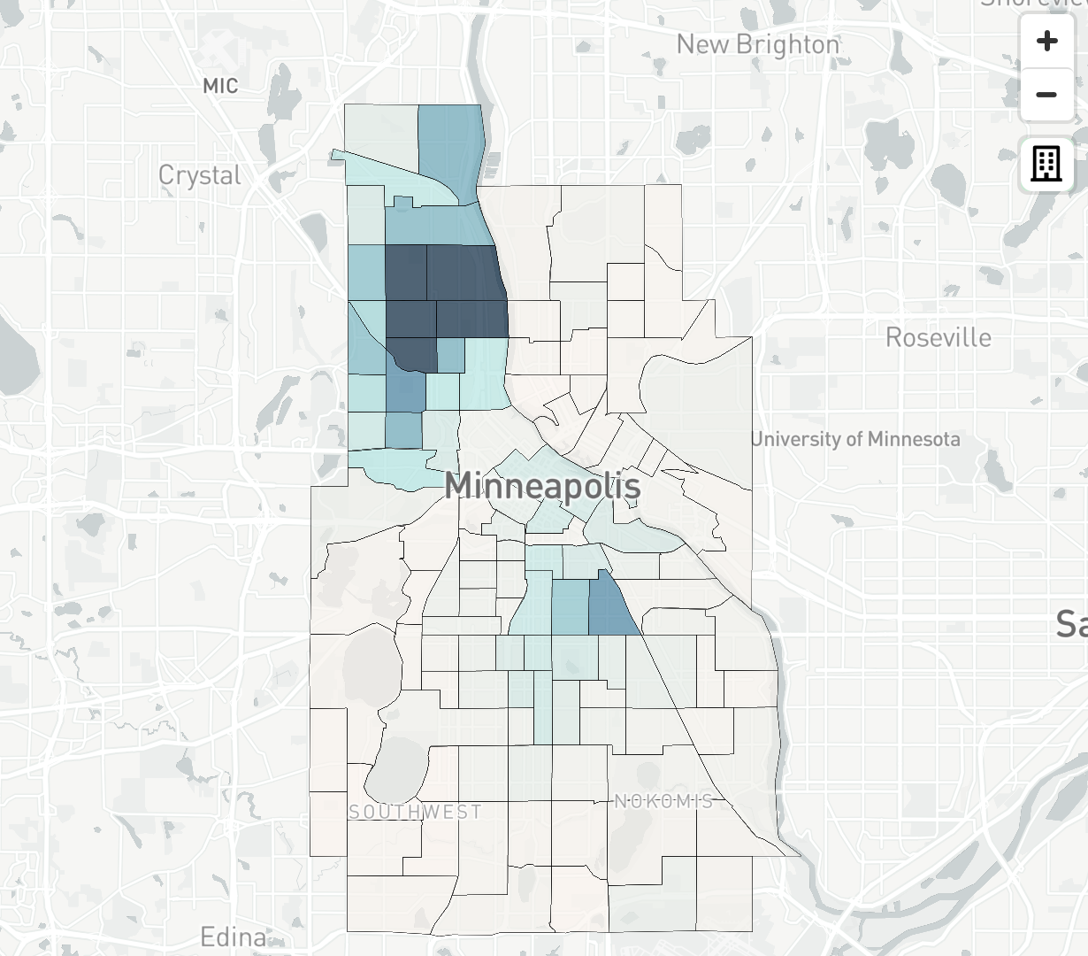

[**EXPLORE THIS**](http://static.startribune.com/news/projects/all/20200510-shots/)

**MEDIAN INCOME BY CENSUS TRACT, 2018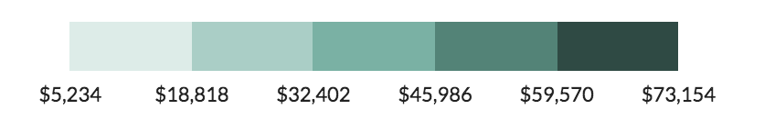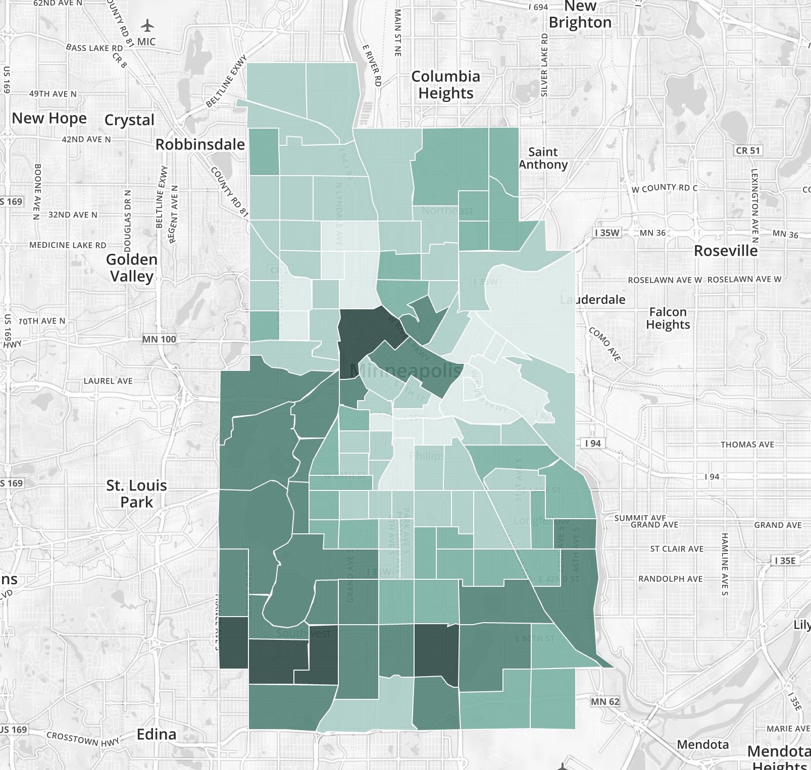**[**EXPLORE THIS**](https://censusreporter.org/data/map/?table=B06011&geo_ids=16000US2743000,140%7C16000US2743000&primary_geo_id=16000US2743000#)

**NON-HISPANIC WHITE POPULATION, 2018**

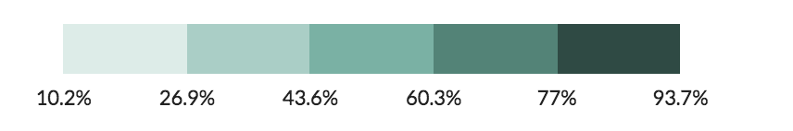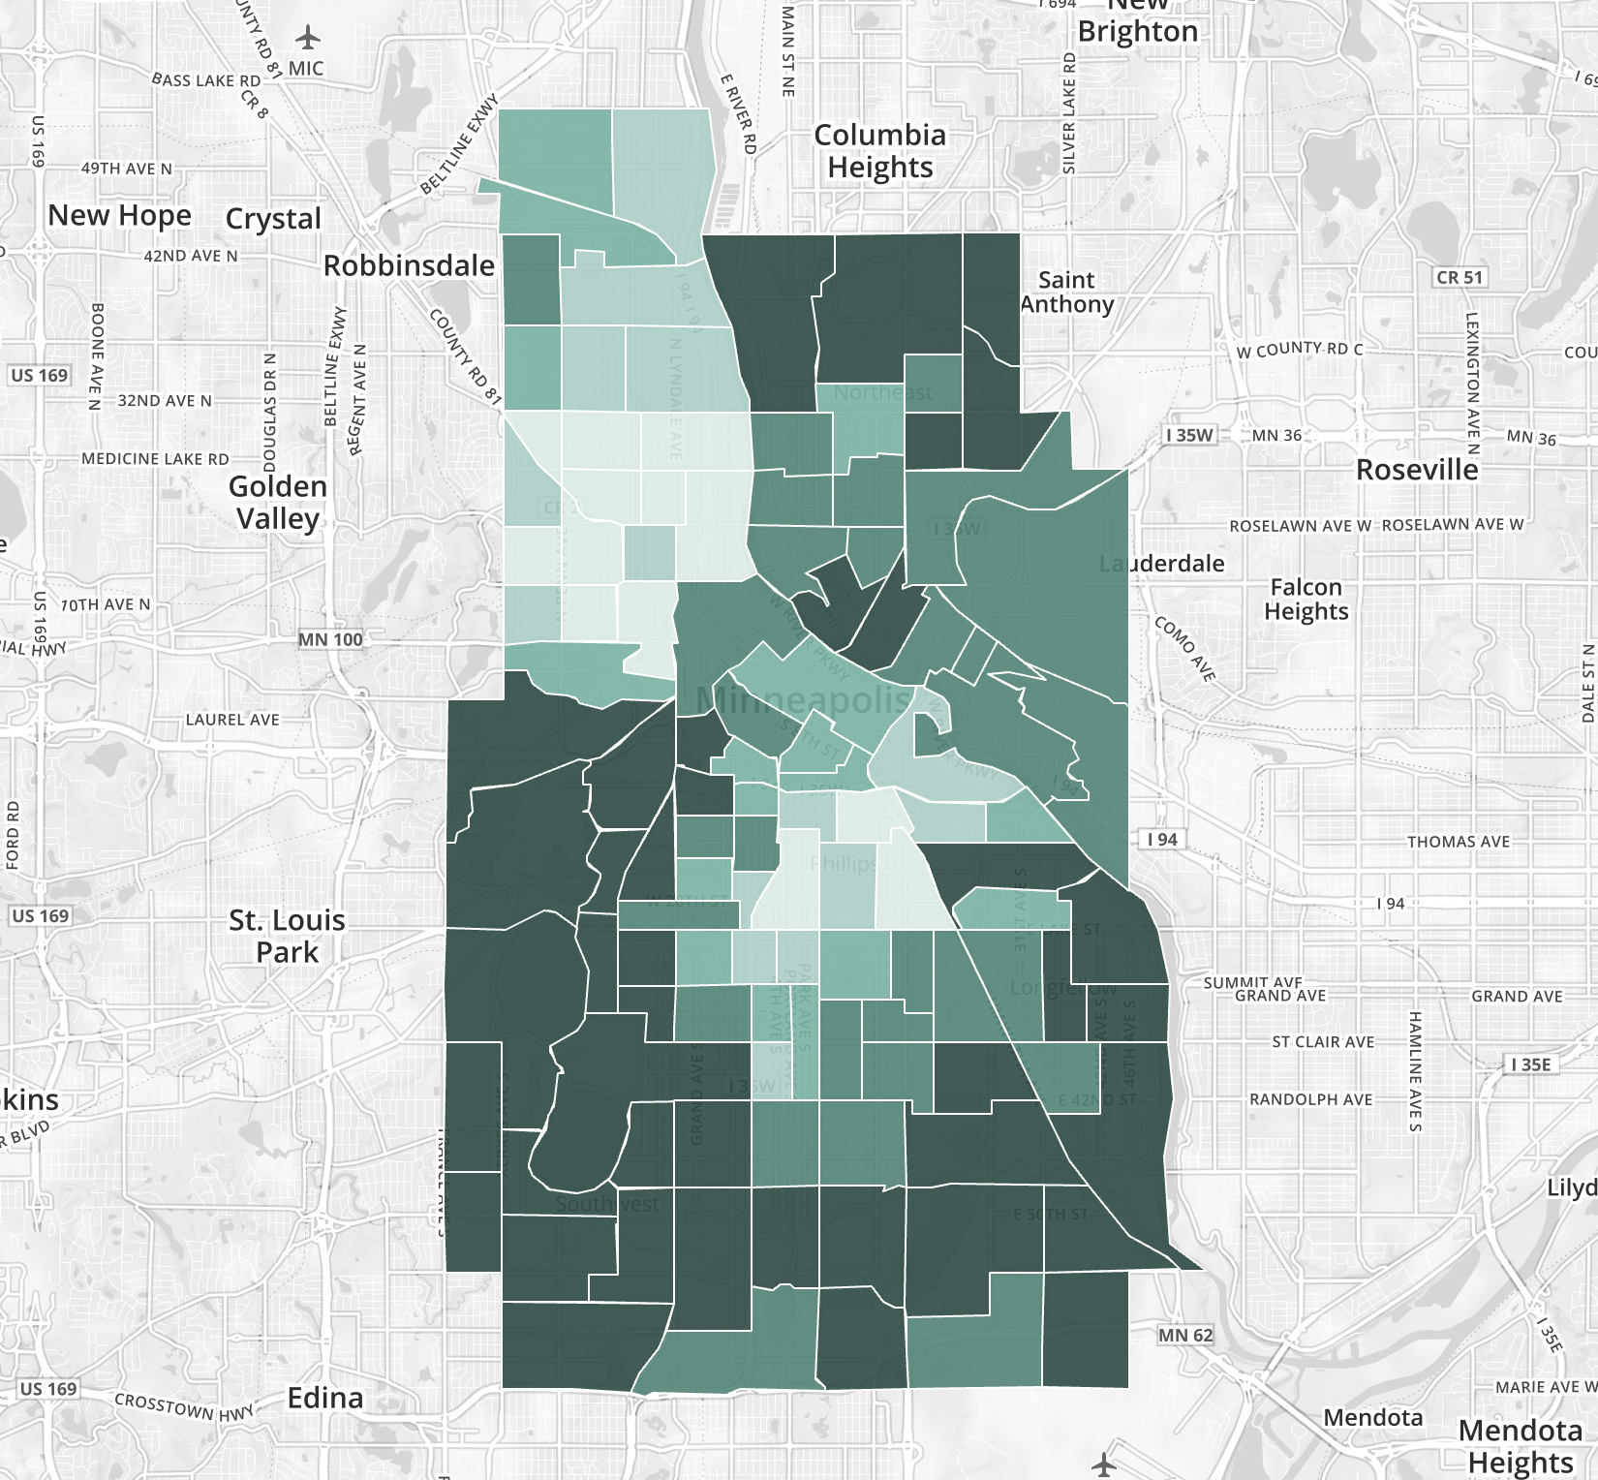

[**EXPLORE THIS**](https://censusreporter.org/data/map/?table=B02001&geo_ids=16000US2743000,140%7C16000US2743000&primary_geo_id=16000US2743000#)

**MEDIAN AGE, 2018**

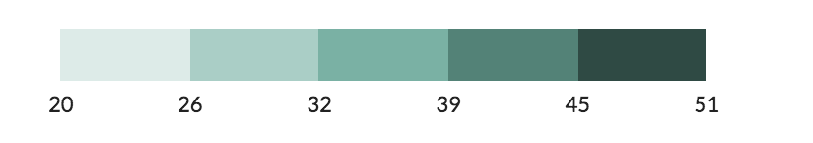

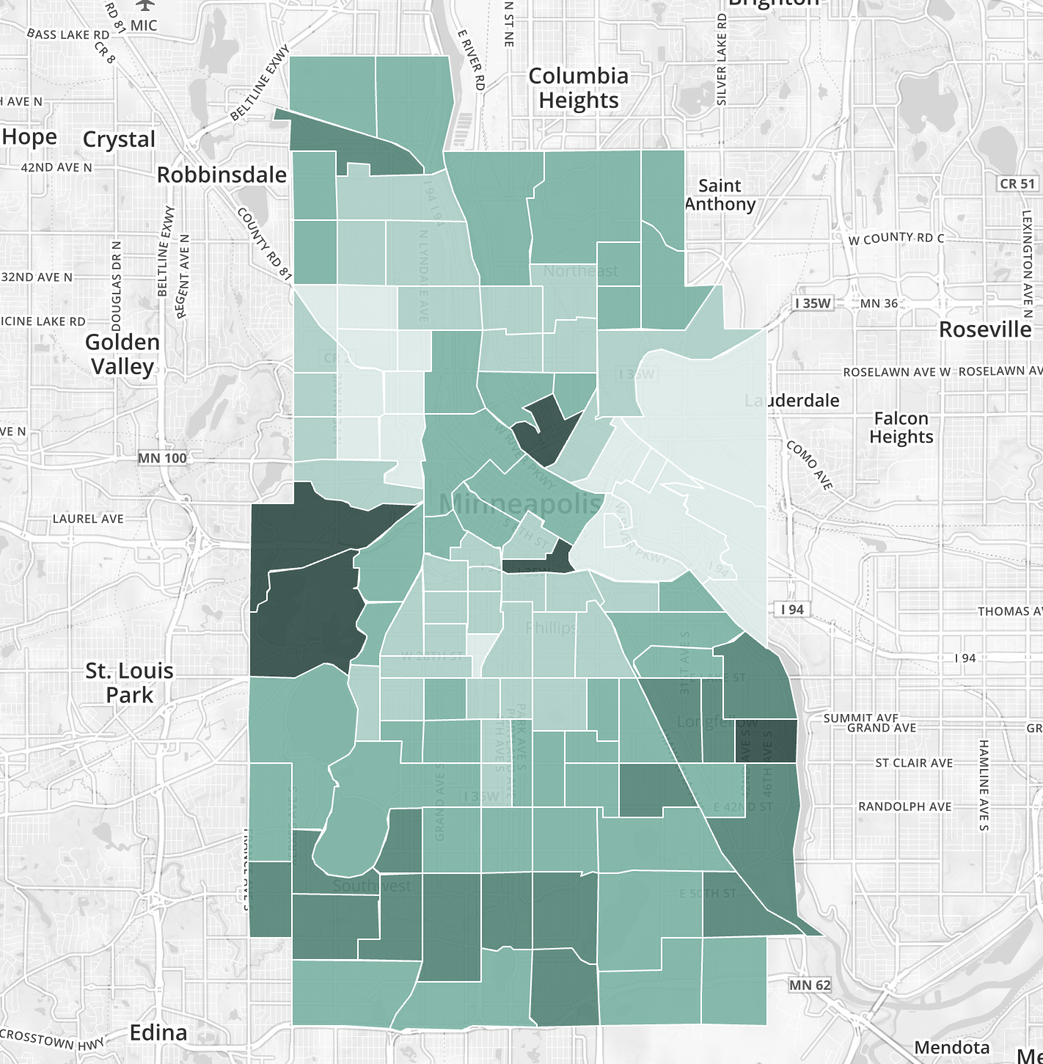

[**EXPLORE THIS**](https://censusreporter.org/data/map/?table=B01002&geo_ids=16000US2743000,140%7C16000US2743000&primary_geo_id=16000US2743000#column%7CB02001002,sumlev%7C140)

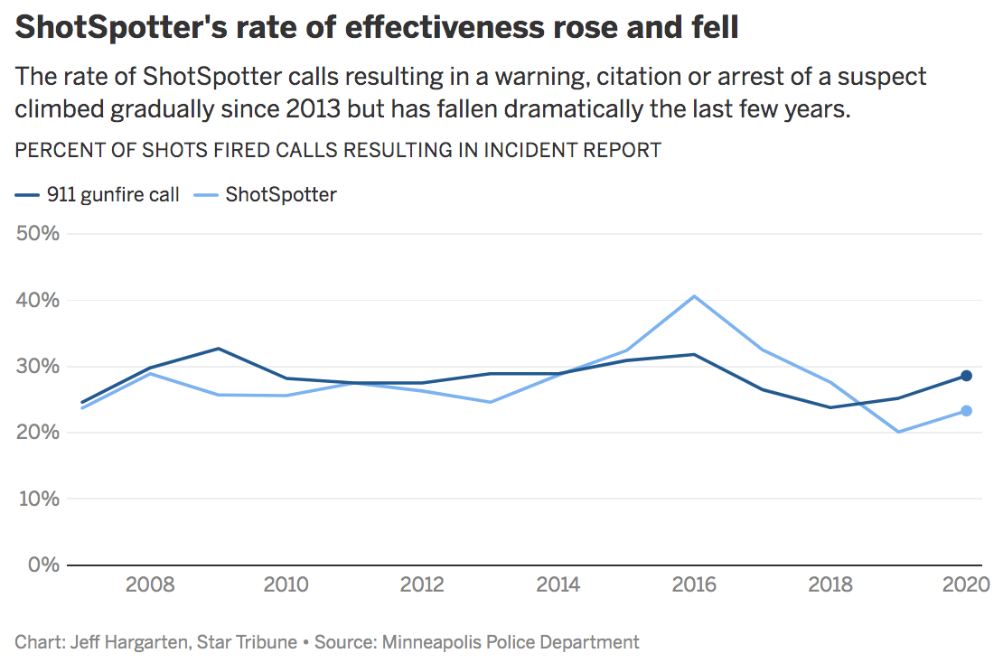

[**EXPLORE THIS**](https://datawrapper.dwcdn.net/jbAzx/)

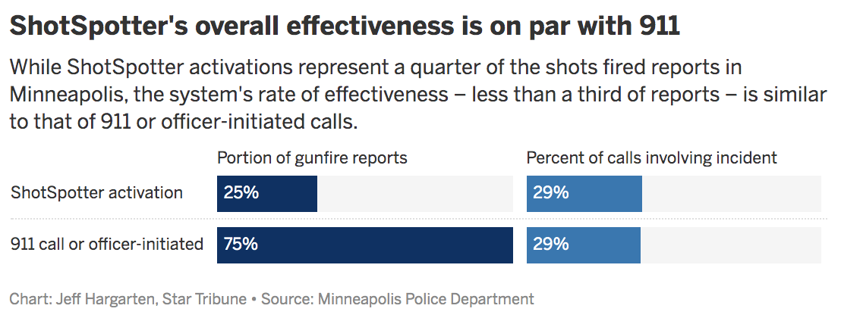[**EXPLORE THIS**](https://datawrapper.dwcdn.net/2ASFv/)

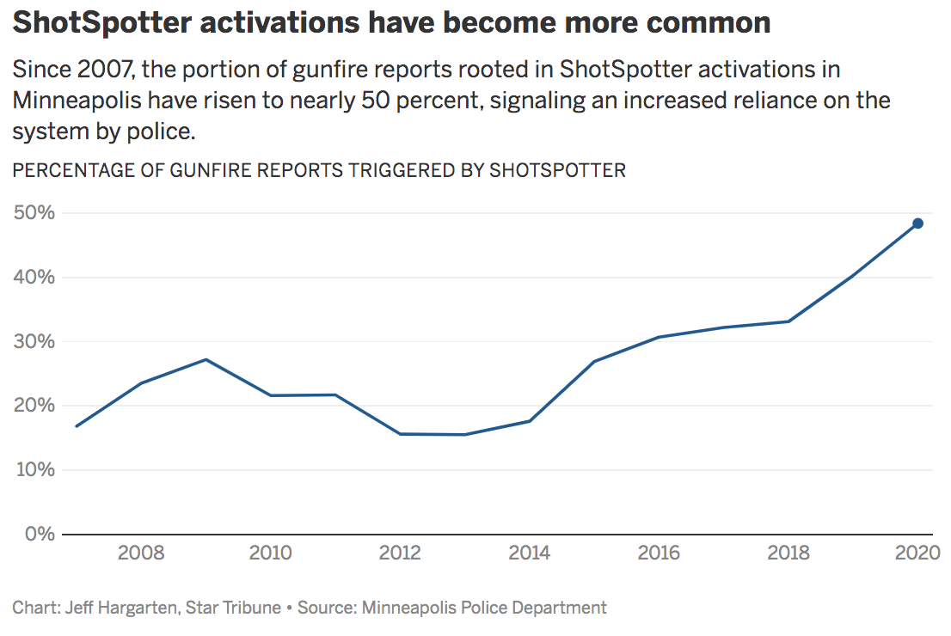[**EXPLORE THIS**](https://datawrapper.dwcdn.net/H4MXc)

**Shots reported by year, 2007-2020  
Shotspotter versus 911/officer-initiated versus total  
  
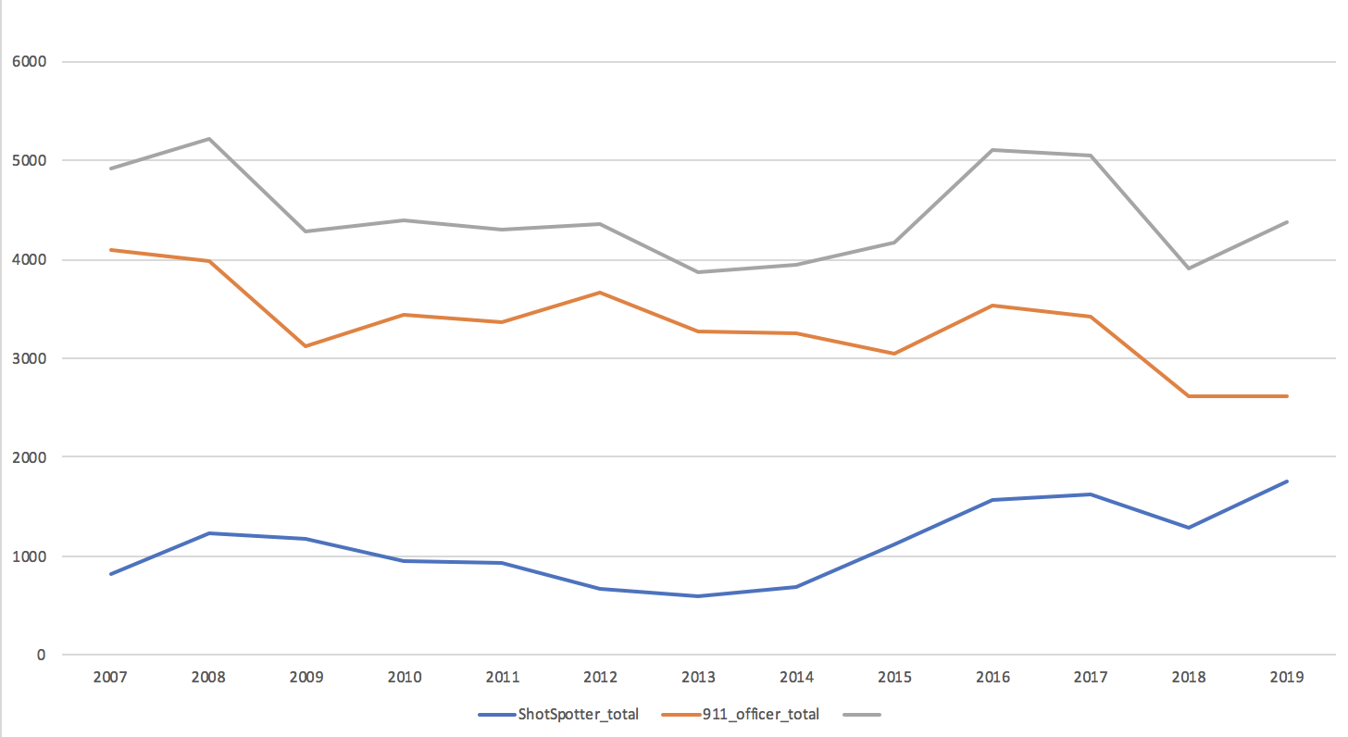**

**Is it gun violence or just noise?**

Shows shots fired reports versus Assault with a Dangerous Weapon incidents by year

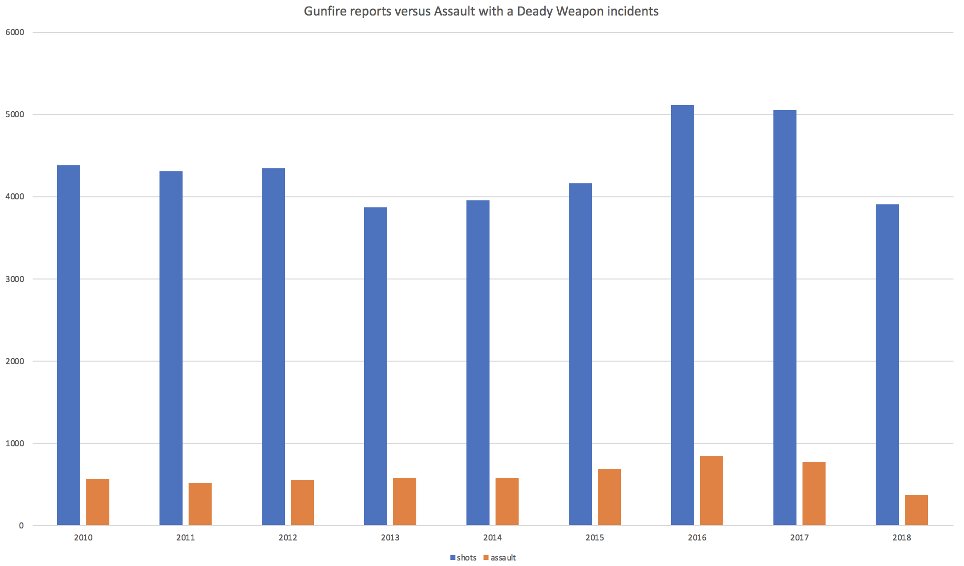

**Assault with a dangerous weapon by neighborhood, 2010-2018**

|  |  |
| --- | --- |
| **neighborhood** | **incidents** |
| DOWNTOWN WEST | 489 |
| JORDAN | 385 |
| HAWTHORNE | 323 |
| WILLARD - HAY | 291 |
| NEAR - NORTH | 271 |
| FOLWELL | 256 |
| EAST PHILLIPS | 210 |
| WEBBER - CAMDEN | 186 |
| VENTURA VILLAGE | 184 |
| WHITTIER | 163 |
| MCKINLEY | 147 |
| MIDTOWN PHILLIPS | 143 |
| CENTRAL | 136 |
| ELLIOT PARK | 116 |
| POWDERHORN PARK | 112 |
| LIND - BOHANON | 108 |
| CEDAR RIVERSIDE | 103 |
| LONGFELLOW | 101 |
| PHILLIPS WEST | 95 |
| LORING PARK | 94 |
| SEWARD | 79 |
| LYNDALE | 68 |
| NORTH LOOP | 66 |
| CORCORAN | 62 |
| CLEVELAND | 58 |
| HARRISON | 54 |
| STEVENS SQUARE - LORING HEIGHTS | 52 |
| LOWRY HILL EAST | 44 |
| MARCY HOLMES | 36 |
| WENONAH | 36 |
| VICTORY | 33 |
| HOLLAND | 30 |
| WINDOM PARK | 29 |
| COMO | 25 |
| KING FIELD | 25 |
| SHINGLE CREEK | 21 |
| CARAG | 20 |
| REGINA | 20 |
| SUMNER - GLENWOOD | 20 |
| HOWE | 19 |
| SHERIDAN | 19 |
| WINDOM | 19 |
| HIAWATHA | 18 |
| BANCROFT | 16 |
| NICOLLET ISLAND - EAST BANK | 16 |
| STANDISH | 16 |
| AUDUBON PARK | 15 |
| BRYANT | 15 |
| PROSPECT PARK - EAST RIVER ROAD | 15 |
| BOTTINEAU | 14 |
| LOGAN PARK | 14 |
| TANGLETOWN | 14 |
| CAMDEN INDUSTRIAL | 13 |
| MARSHALL TERRACE | 12 |
| MORRIS PARK | 12 |
| DOWNTOWN EAST | 11 |
| EAST ISLES | 11 |
| WAITE PARK | 11 |
| ST. ANTHONY EAST | 10 |
| ST. ANTHONY WEST | 10 |
| NORTHROP | 9 |
| BELTRAMI | 8 |
| ERICSSON | 7 |
| COLUMBIA PARK | 6 |
| UNIVERSITY OF MINNESOTA | 6 |
| ARMATAGE | 5 |
| COOPER | 5 |
| DIAMOND LAKE | 5 |
| KEEWAYDIN | 5 |
| MINNEHAHA | 5 |
| CEDAR - ISLES - DEAN | 4 |
| ECCO | 4 |
| FIELD | 4 |
| WEST CALHOUN | 4 |
| BRYN - MAWR | 3 |
| LOWRY HILL | 3 |
| MID - CITY INDUSTRIAL | 3 |
| NORTHEAST PARK | 3 |
| EAST HARRIET | 2 |
| HALE | 2 |
| KENWOOD | 2 |
| PAGE | 2 |
| FULTON | 1 |
| LYNNHURST | 1 |